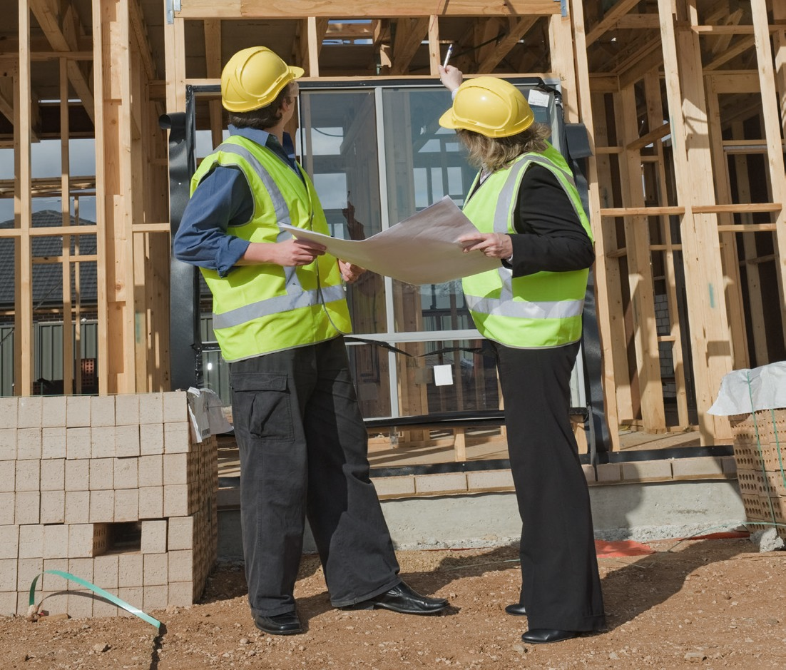  - Loans of $250,000 to $10 million  or more  - As little as 10% down with a full 20-year payout  - Quick approval  - No Exorbitant up-front fees  - Excellent rates  - 24–48-hour approvals  - Rates from 4.20% to 6.75%  - Purchase, Refinance & Cash-Out  - Most Commercial Properties Considered  - Nationwide Programs  Real Estate Program Highlights |  | 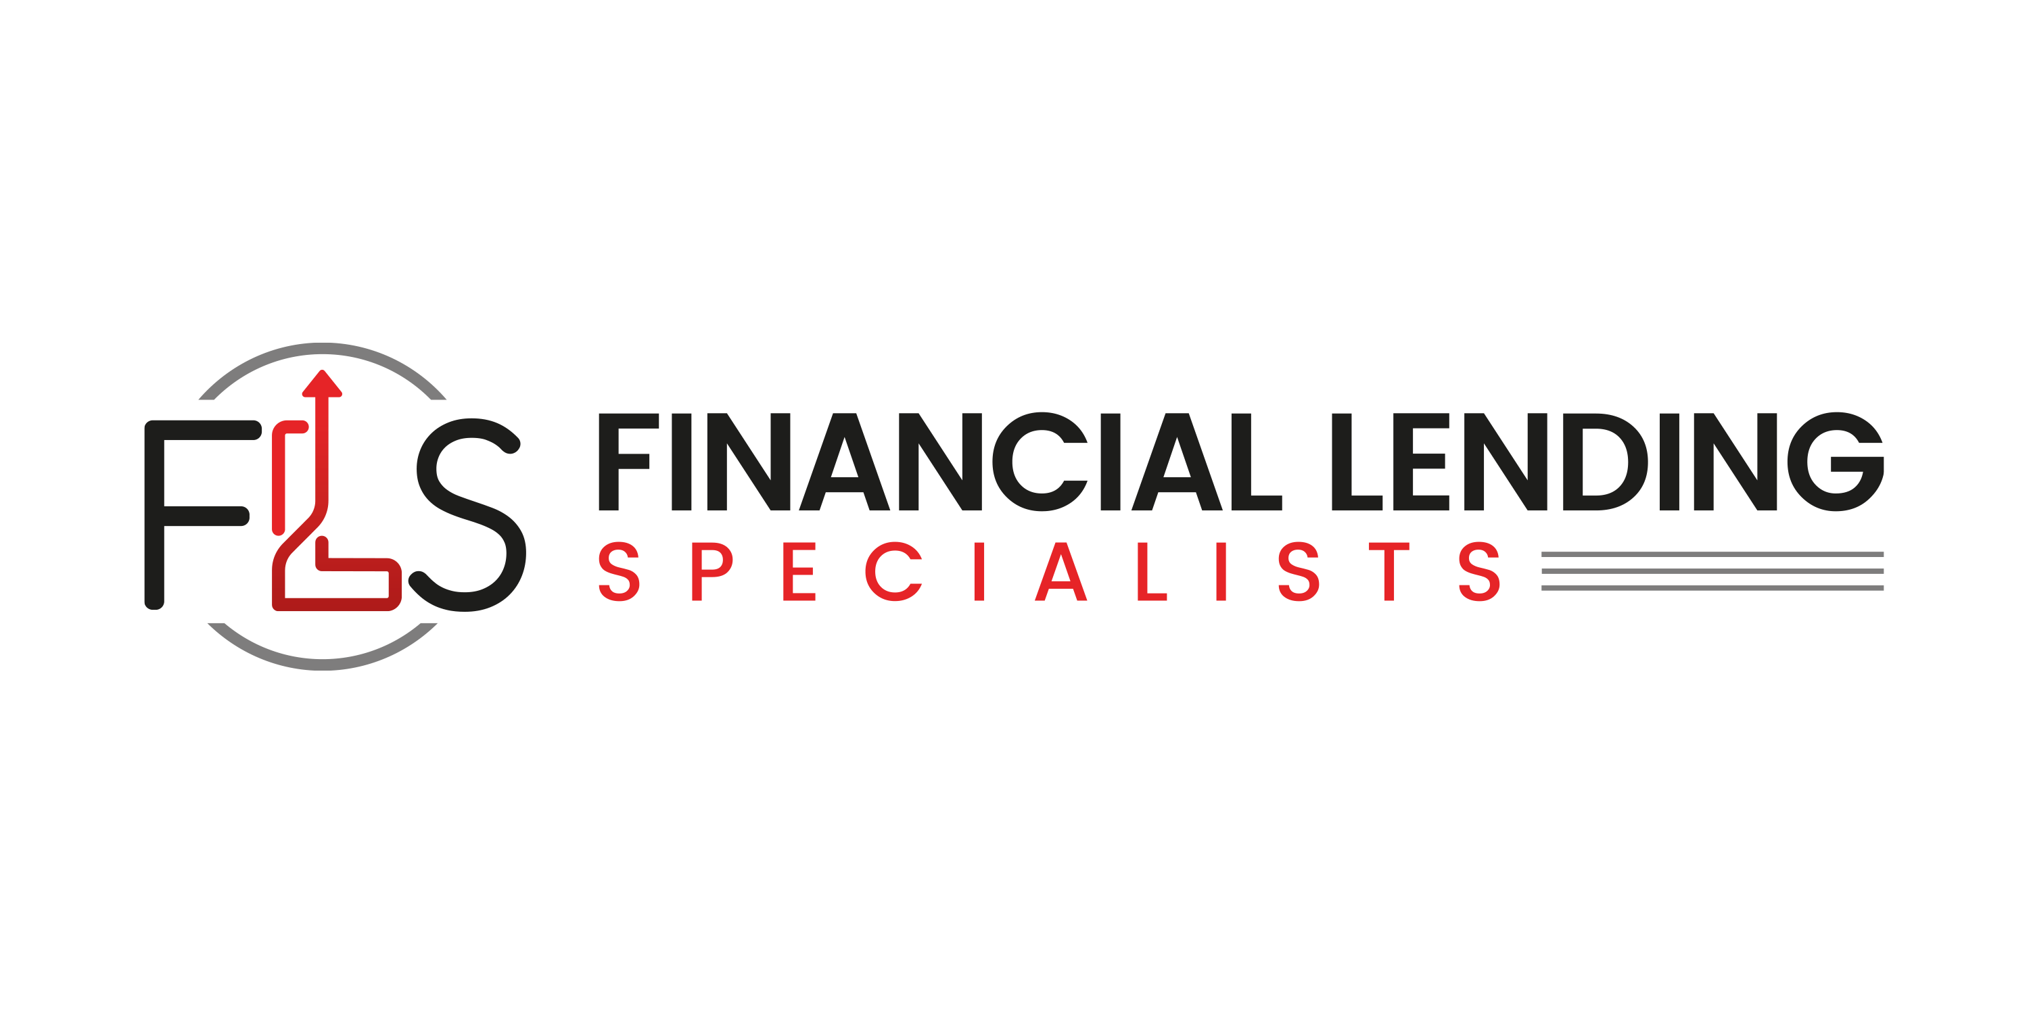      REAL ESTATE FINANCING  Purchase your building for as little as 10% down!  Loans Ranging From $250k to $10mm Available Today
  A partial list of the many services that we provide:
  - Business Acquisition Financing
  - Church Financing
  - Commercial Bridge Loans
  - Construction Equipment Financing
  - Debt Restructuring
  - Easy Pay Cash Advance
  - Equipment Leasing
  - Real Estate Financing
  - SBA Loans
  - Security-Based Lending
  - Unsecured Business Loans & Lines of Credit
  We can provide almost any type of financing a business owner needs!
  Financiallendingspecialists.com
  323-285-3721
  info@financiallendingspecialists.com
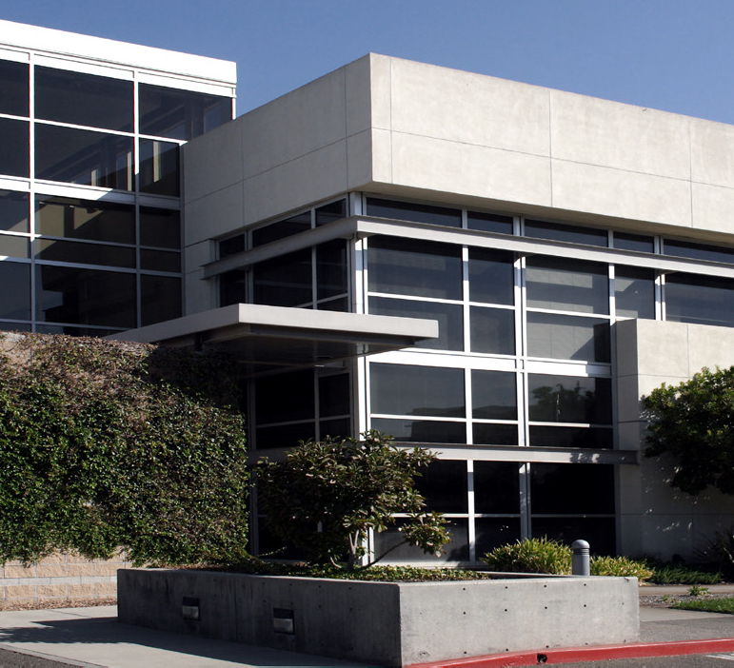 | Our premium customer service and attention to detail makes the commercial loan process simple for borrowers as well as commercial finance professionals. We can provide a quick turnaround, sometimes as little as 24-48 hours for approval.  Our Objective  While other lenders are turning down most commercial transactions, our comprehensive approach enables us to offer loans for more borrowers and on more transaction types. In addition to being able to finance hard to place transactions, we offer loan programs for investors, owners or companies seeking financing on strong, superior, or weak credit-grade transactions.  Contact us today if you have a property you would like financing for! |   For More Information  Visit Us Online  financiallendingspecialists.com
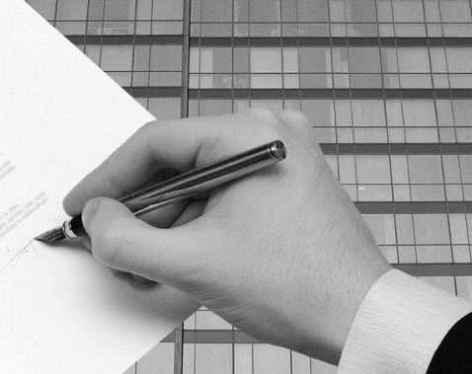

Who We Are

We are a private commercial lender and structured finance company that offers financing to borrowers directly and through a network of finance professionals. We feature a variety of commercial loan programs to accommodate borrowers’ needs, with loan limits ranging from $250,000 to $10 million plus with as little as 10% down.

Our Philosophy

Unlike many other companies, we are focused on the commercial finance niche and recognize the difficulty brokers and borrowers experience locating financing for their commercial transactions in the current market.
Our company implements a tiered approach to provide our clients with the best options possible.

